DataMites Notes Theory
Data Science is the field of study that combines domain expertise, programming skills, and knowledge of mathematics and statistics to extract actionable insights (Insights from Data)
Evolution of Data Science
1960- Centralized Mainframe
1980s- Data Warehouse
1990s- business Intelligence
1995- Data Mining
2005-10- Excel SQL BI tools under Business Analytics
2015-Current Data Science

Big Data Vs Data Science Vs Business Analytics
Big Data – is data with size, speed relevance type reliable/quality or Volume velocity variety value veracity. These are characteristics of big data thus turning this into Big Data analytics.
Data Science- involves Programming/ Code, uses both Structure and unstructured data, extensively involves Machine Learning and Artificial Intelligence as Tools. (Non-Tabular. Images, text, post on a forum, etc.)
Business Analytics – Minimal/no coding required. Uses mostly structured data, traditional statistical and forecasting techniques.
Analytics Classification- specific topics that highlight important facts and information describing specific data.
Descriptive Analytics- describing important facts.
Predictive Analytics- analyzing future information.
Diagnostic Analytics- specifying information to help break down.
Doman Analysis- It is necessary to understand the domain prior to proceeding. This helps to gain a business perspective on the analysis which follows.
Exploratory Data Analysis- EDA allow us to arrive at patterns and relationships within the data. This includes the use of visual tools graphical analysis.
Data Preparation- is known as Data Preprocessing, this is an essential stage of data Science. Once the data is prepared, we may use it to preform Predictive analytics
Machine Learning is a field of computer science that gives computers the ability to learn without being explicitly programmed.
LLM(Large Language Models)
Artificial Intelligence is the simulation of human intelligence in machines that are programmed to think and learn like humans
AI was thought of around 1956 by a professor in a paper
Reinforcement Learning is a type of machine learning where an agent learns to make decisions by taking actions in an environment to maximize cumulative rewards. Examples: Gaming robotics and autonomous systems
GANS (Generative adverse network) are class of artificial intelligence algorithms used in unsupervised machine learning for generating synthetic data. Applications: Image generation, style transfer, and data augmentation.
Generative Passive Model- Class of generative models that create new data instances without the need for explicit training.
Techniques: Rule-based systems, Procedural generation, and evolutionary algorithms Applications: Content generation, Level design, and creative arts
Retail: Machine learning in Retail: what to stock how much to buy what products to suggest to repeat customers. But doing more with that data using machine learning is just what retailers need to really succeed in the current market.
AI in banking: Fraud transactions Detection, Predicting risk of asset class based on future context models. More personalized and faster customer experiences
Statistics Notes
The Science of collecting describing and interpreting data is popularly known as statistical leveraging in Data science.
Descriptive statistics- Methods of organizing, summarizing, and presenting data in an informative way
Inferential statistics- The methods used to determine something about a population on the basis of a sample
Descriptive Statistics are methods for organizing and summarizing data. For example, tables or graphs are to organize data, and descriptive values such as the average score are used to summarize data. A descriptive value for a population is called a parameter and a descriptive valued such as the average scores are used to summarize data.
A descriptive value for a population is called a parameter and a descriptive value for a sample is called a statistic.
Inferential Statistics are methods for using sample data to make general conclusions (inferences) about populations.
Because a sample is typically only a part of the whole population, sample data provide only limited information about the population. As a result sample statistics are generally imperfect representatives of the corresponding population parameters.
Inference is the process of drawing conclusions or making decisions about a population based on sample results
Population: A collection, or set, of individuals or objects or events whose properties are to be analyzed.
Two kinds of populations: finite or infinite
Sample: A subset of the population.
Variable: A characteristic about each individual element of a population or sample.
Data (singular): The value of the variable associated with one element of a population or sample. This value may be a umber, a word, or a symbol.
Data (plural): the set of values collected for the variable from each of the elements belonging to the sample.
Random Variable: Variable are placeholder where you can store anything. It can number, or string, sentences.
Experiment: a planned activity whose results yield a set of data.
Parameter: A numerical activity value summarizing all the data of an entire population.
Statistic: A numerical value summarizing the sample data

Data
Quanitative
Numerical (Made of Numbers: Age, weight, number of objects) ->
Decimal:
Continuous (Infinite, Option, Age, weight, Blood pressure) <->
Whole:
Discrete (Finite Options Shoe size number of objects)
Qualitative
Categorical (Made of words: Eye color, Gender, blood type, Ethnicity) ->
Ordinal (data has a hierarchy Pain severity, Satisfaction rating, mood) <->
Nominal (data has no hierarchy, eye color, dop breed, blood type)
Types of sampling
Probability Sampling -> Non – Probability Sampling
Simple Random Sampling -> Stratified Random Sampling -> Cluster Random Sampling -> Mulit-stage Random Sampling
Methods Used to Collect Data
Experiment: The investigator Controls or modifies the environment and observes the effect on the variable under study
Survey: Data are obtained by sampling some of the population of interest. The Investigator does not modify the environment.
Census: A 100% survey. Every Element of the population is listed. Seldom used: difficult and time-consuming to compile, and expensive.
Judgement Samples: it is non-probability sampling technique in which the sample members are chosen only on the basis of the researcher’s knowledge and judgement.
Probability Samples: Samples in which the elements to be selected are drawn on the basis of probability. Esch element in a population has a certain probability of being selected as part of the sample.

Steps involved in Descriptive Statistics
Collecting the data
Presenting the data visualization using Matplotlib and Seaborn.
Summarizing the data Module 3
Sampling Error
The discrepancy between a sample statistic and its population parameter is called sampling error.
Defining and measuring sampling error is a large part of inferential
Mean Median and Mode
The Mean is the average of all numbers and is sometimes called the arithmetic mean
The Statistical Median is the middle number in a sequence of numbers. To find the median, organize each number in order by size; the number in the middle is the median
The Mode is the number that occurs most often within a set of numbers
Standard deviation (SD) is the square root of Variance – It tells you how much data varies from the mean in the original units
Interquartile Range (IQR) Range
The Interquartile range is the middle half of the data. Mathematically the iterquartile range includes the 50% of data points that fall between Q1 and Q3
Normal Distribution, also known as the Gaussian distribution, is a probability distribution that is symmetric about the mean, showing that data near the mean are more frequent in occurrence then data far from the mean.
Properties Of normal Distribution
- Empirical Rule
- Distortion in Normal Distribution
- Central Limit Theorem
- Standard Normal Distribution
- Outliers
- QQ plot
- Log, Sqrt, Boxcox transformation
The empirical rule states that for a normal distribution, nearly all of the data will fall within three standard deviations of the mean. The empirical rule can be broken down into three parts:
- 68% of data falls with the first standard deviation from
- 95% fall within two standard deviations (2 sigma)
- 99.7% fall within three standard deviations (3 sigma)
- Any points lying after 3 sigma is outliers.
Distortion in Normal Distribution
The distortion in normally distributed curves can be quantified in 2 ways
- Skewness
- Kurtosis
Skewness in Normal Distribution
Skewness is asymmetry in a statistical distribution, in which the curve appears distorted or skewed either to the left or to the right. Skewness can be quantified to define the extent to which a distribution differs from a normal distribution
Kurtosis in Normal Distribution
In Probability theory and statistics kurtosis is a measure of the “tailedness” of the probability distribution of a real-valued random variable.
Outliers An outlier is an observation point that is distant from other observations. An Outlier may be due to variability in the measurement or it indicate experimental error; the latter are sometimes excluded from the data set.
Central Limit Theorem (CLT)
The central limit theorem states that the distribution of sample means approximates a normal distribution as the sample size gets larger (assuming that all samples are identical in size), regardless of population distribution shapes. CLT in one line mean
“Even if I’m not normal, the average is normal”
The distribution of the mean value is normal. The average of the mean values curve in a graph is known as sampling distribution of the mean.
Standard Normal Distribution (SND)
The standard normal distribution is a special case of the normal distribution a normal random variable has a mean of zero and a standard deviation of one.
SND Major property “range is from -3 to +3 Standard Deviation = 1 and mean =0”
Converting from normal distribution (ND) is standardized or scaling to the standard normal distribution (SND) converting the data is scaling from ND to SND so that is the -3 to +3 and the process is called Standardization. What is the property of ND? What is the purpose of SND? Are interview questions. To get the better performance we are going to with the scaling. Zed score (zscore) is nothing but -3 to +3. ND the mean equal to mode equal to median based on the data set.
ND is known are gaussian distribution which is the bell-shaped curve so the mathematical formula is Mean is equal to mode is equal to median.
Empirical Rule has the percentage to 68% most of the percentage 95% 99.7%
Two type Distortions in ND which is Skewness and Kurtosis
Skewness – the shape is not the bell curve of the outliers
Kurtosis - the peak of the bell curve k<3 k=3 K>3
Correcting Distortion in Normal Distribution
Transformation is nothing but taking a mathematical function and applying it to the data.
Log transformation [each data point is replaced with log(x) to obtain ND]
Square-Root Transformation [Each data point is replaced by its square root]
Reciprocal Transformation [It takes the inverse of x ie., 1/x]
Box-Cox Transformation [Transformation of non-normal dependent variables to normal shape]
Reason: To transform the data to either reduce the skewness or to normalize the data or simply make the data easier to understand.
Q-Q Plots
Q-Q plots are used to find the type of distribution for a random variable whether it be a Gaussian Distribution/ Normal Distribution or not.
If my data is within the reference line then it is ND
When the data is slightly skewed and not ND for example (like half the line is above or below) then our data is not ND.
Why we need to convert ND to SND? To get better Scaling
Z-Score/ Z-value/Standard Score
A Z-score (aka, a standard score) indicates how many standard deviations an element is above or below from the mean. A z-score can be calculated from the following formula Z=(X-u)/S
Interview question: What is the formula with respect to Z-Score?
Z-score = X(datapoint) – mean/ Standard Deviation
Based on Z-score we can calculate the probability value.
What is a Probability Density Function (PDF)?
A Probability Density Function (PDF) Describes the likelihood of a continuous random Variable taking on a specific range of values for continuous data.
For continuous data:
- The Probability at a single point is zero
- Probability is calculated over an interval
- The Area under the curve between two values gives the probability of falling in the range
The total area under the curve = 1, representing 100% probability.
Probability Density Function
Probability density is the relationship between observation and their Probability.
The overall shape of the probability density is referred to as a probability distribution, and the calculation of probability for specific outcomes of a random variable is preform by a probability density function for Normal distribution is given as
F(x | μ, σ²) = 1/√(2πσ²) *e – (x-μ)²/2π²
μ is the mean or expectation of the distribution (and also it median and mode
σ is the standard deviation
σ² is the variance
CDF: It provides a shortcut for calculating many probabilities at once. We integrated the PDF Functions to get the cumulative probability.
Euclidean Distance
It is a classical method to calculate the distance between two object X and Y in the Euclidean space (1- or 2- or n- dimension space). Thiw distance can be calculated by traveling along the line, Connecting the points.
D = √(x₂-x₁)² +(y₂-y₁)²
Your can use the Pythagorean Theorem to Compute this distance.
Manhattan Distance
It is similar to the Euclidean Distance, But the Distance (for example, two points, Separate by building block in a city) is calculated by traversing vertical and horizontal lines in the grid-base system.
Formula is:
D = |x₂ - x₁| + |y₂ - y₁|
Minkowski Distance
It is a metric on the Euclidean space and can be considered as a generalization of both the Euclidean and Manhattan distances
Formula:
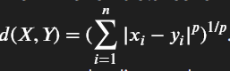
When p = 1; it computes the Manhattan Distance
When p = 2; it computes the Euclidean Distance.
Interview question: how to Identify the distance between the two data points?
Covariance
It is the relationship between a pair of random variables where changes in one variable cause change in another variable.
It can take any value between -∞ to +∞, where the negative value represents the negative relationships whereas a positive value represents the positive relationship
Formula for Population:
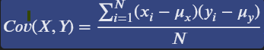
Formula for samples:
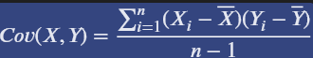

X and Y are the mean of the sample set
N is total # of sample
X1 and y1 = individual sample of set
Correlation
It is the scaled version of Covariance. Correlation is a step ahead of the covariance as it quantifies the relationship between two random variables. In simple terms, it is a unit measure of how these variables change concerning each other (normalized covariance value)
Correlation Formula:
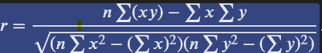

Based on the correlation coefficient, we can select the important features. It the independent feature is not correlated with the target variable, we could remove that feature. Or if two independent features are highly correlated, we could remove anyone feature
Hypothesis Testing
Hypothesis testing is a way for scientist or researches to test ideas or claim using data this of it like a trial you make a claim(the hypothesis) collect evidence (data) and then decide if your claim makes sense based on the evidence.

P-value is the probability Value
Three types of Tests A two till test, then left tail test and right tail test

Definition of Hypothesis Testing
- Hypothesis: A guess or claim you test.
- Null Hypothesis (H₀): the claim you’re testing (usually that nothing has changed).
- Alternative Hypothesis (H₁): The opposite of the null (something has changed).
- Significance Level (a): A cutoff (like 5%) to decide if the result is rare or not.
Steps of Hypothesis Testing
- State the Hypotheses
  - Whatever the claim they have is called a Null Hypothesis (H0)
  - Alternative Hypothesis (H1) means the opposite the claim
  - Person 1 claim that student eat 2 apples a day (Null Hypothesis)
  - Person 2 claim that student eat less than 2 (Alternative Hypothesis)
- Collect Data
Ask 30 students how many apples they eat per day and find the Average.
- Analyze the data
Use math (like calculating the mean and standard deviation) to check if the new average is significantly different from 2.
- Make a decision
  - If your result shows a big enough difference, you can reject the null hypothesis.
  - If not you fail to reject it – meaning the canteen’s claim might still be true.
Two Types of Error (False Positive)
You reject H₀ even though it’s actually true
  - It’s like punishing an innocent person.
  - The chance of making this error is called alpha (a), usually 5%.
Type II Error (False Negative)
You fail to reject H₀ even though it’s actually false.
  - It’s like letting a guilty person go free.
  - The chance of this error is called beta (b)

Hypothesis Testing
Hypothesis testing is a method used to make decisions using data. It helps us decide whether a claim about a population is likely to be true.
- Set up Null Hypothesis
  - H₀ (Null Hypothesis). The Statement we test (no change/no effect)
  - H₁ (Alternative Hypothesis). What we want to prove (there is a change/effect)
- Decide the significance Level (a)
  - Common Choices: 0.05 (5%) or 0.01(1%)
- Select the Right Test
  - Use Z-test if population standard deviation is known
  - Use T-test if population standard deviation is unknow and sample size < 30
- Calculate the Test Statistics (Z or T-Test)
  - Formula for Z-Score
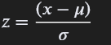
  - Formula for T-Score
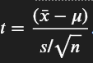
- Find the P-value
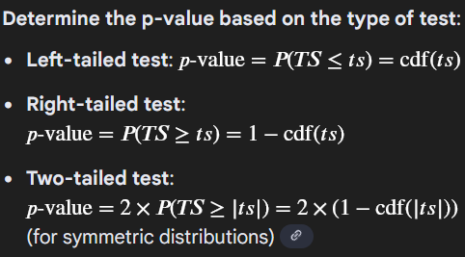
- Compare p-value and alpha
  - If P < alpha reject the null hypothesis
  - If P > alpha accept the null hypothesis

One-Way ANOVA
- Test if there a significant difference in average scores among three different Classes of students.
Step 1: Calculate Group Means
  - Mean A
  - Mean B
  - Mean C
  - Grand Mean (GM)
Step2: Sum of squares
  - Between groups (SSB)
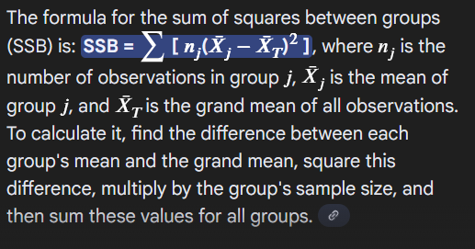
  - Within Groups (SSW)
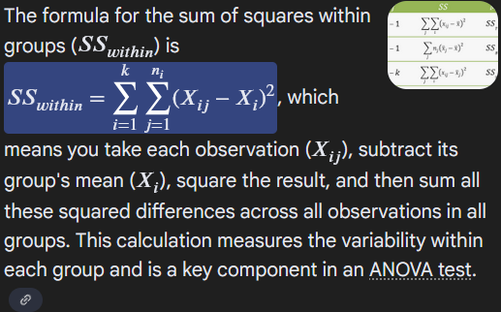

  - F-Ratio
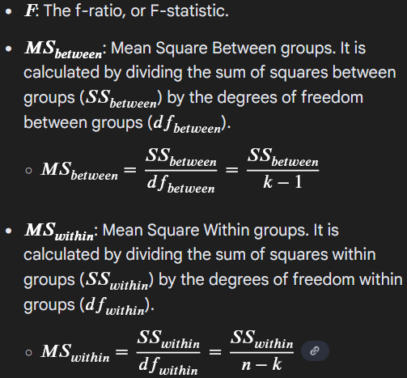
Chi-Square test (X² Test)
The Chi-square (x²) test is a statistical method used to
  - Compare observed values with expected values.
  - Check if there is a significant association between two categorical variables.
- There are two main types
- Chi-square Goodness-of-Fit Test – Tests how well observed data fits an expected distributions.
- Chi-square Test of Independence – Test if two variables are related in a contingency table.

Heat map whether there is a strong correlation or not.
In case alpha is 0.05 or 5% in a two tail just spilt the values

Last Week of Notes
bin is a range of values that data point is grouped into. it is a way to categorize continuous data into discrete interval, for example if you are analyzing exam scores and u might create bins like 0-20,21-40,41-60,61-80, 81-100 each bin represent a range of score and height of bar show how many students scored within range

